AWS IAM Restricted Privilege Documentation

1. Objective
To create an AWS IAM user with restricted privileges so that the user can access only Amazon EC2, with EC2 access further restricted to the Mumbai AWS Region (ap-south-1). The configuration is verified using both the AWS Management Console and AWS CLI.

2. Question
The task requirements are:
- Create an IAM user from the Root AWS account.
- Set the policy or permission to the user, so that it can only access AWS EC2 service. [Restricted Privileges]
- Login as the IAM user and verify the working of the policies attached with the user.
NOTE: Try the following:
- IAM user with AWS Management Console access
- IAM user with Programmatic access
- Restrict the IAM user's EC2 access to the Mumbai AWS Region (ap-south-1)

3. Creating the IAM User
The IAM user named sanjid123 was created from the AWS Root/Admin account. AWS Management Console access was enabled for the user.

4. Configuring EC2 Restricted Permissions
A custom IAM policy named EC2-Mumbai-Only was created and attached to sanjid123. The policy allows EC2 actions only when the requested AWS Region is ap-south-1.
Policy used:
{
"Version": "2012-10-17",
"Statement": [
{
"Effect": "Allow",
"Action": "ec2:*",
"Resource": "*",
"Condition": {
"StringEquals": {
"aws:RequestedRegion": "ap-south-1"
}
}
}
]
}

5. AWS Management Console Access
The IAM user sanjid123 was used to sign in to the AWS Management Console. The EC2 service was accessible, confirming that the assigned EC2 permissions were working.

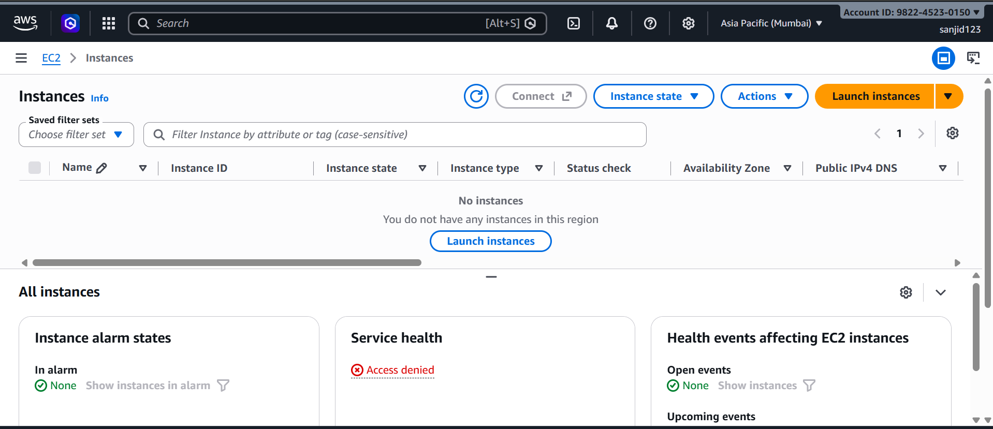

6. Testing Access to Other AWS Services
Access to services outside EC2 was tested to confirm that the user had restricted privileges. When the user attempted to access Amazon S3, the request was denied because the attached policy does not grant S3 permissions.

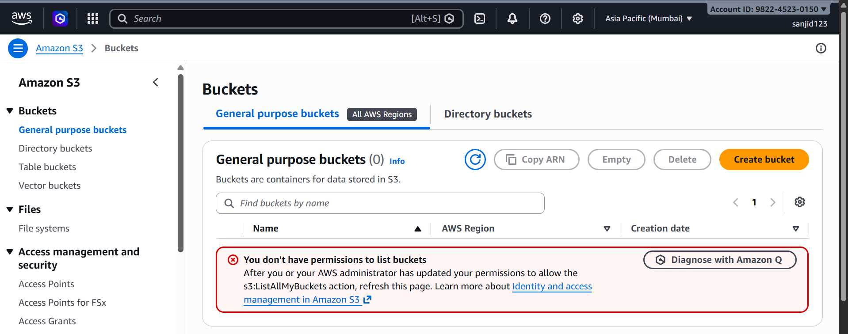

7. Region Restriction Verification
The EC2 permissions were restricted to the Mumbai AWS Region (ap-south-1). EC2 access in Mumbai was successful, while an EC2 request in another region was denied.

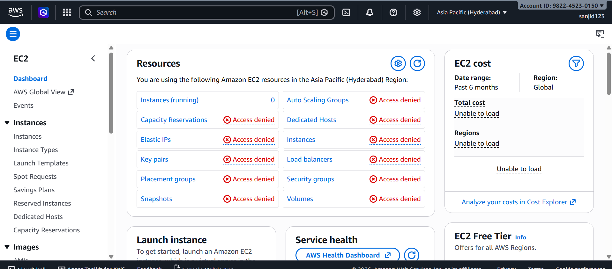

8. Programmatic Access
Programmatic access was configured for sanjid123 by creating an AWS access key. The AWS CLI was installed on the Windows computer and configured using the IAM user's access key, secret access key, and default region ap-south-1.

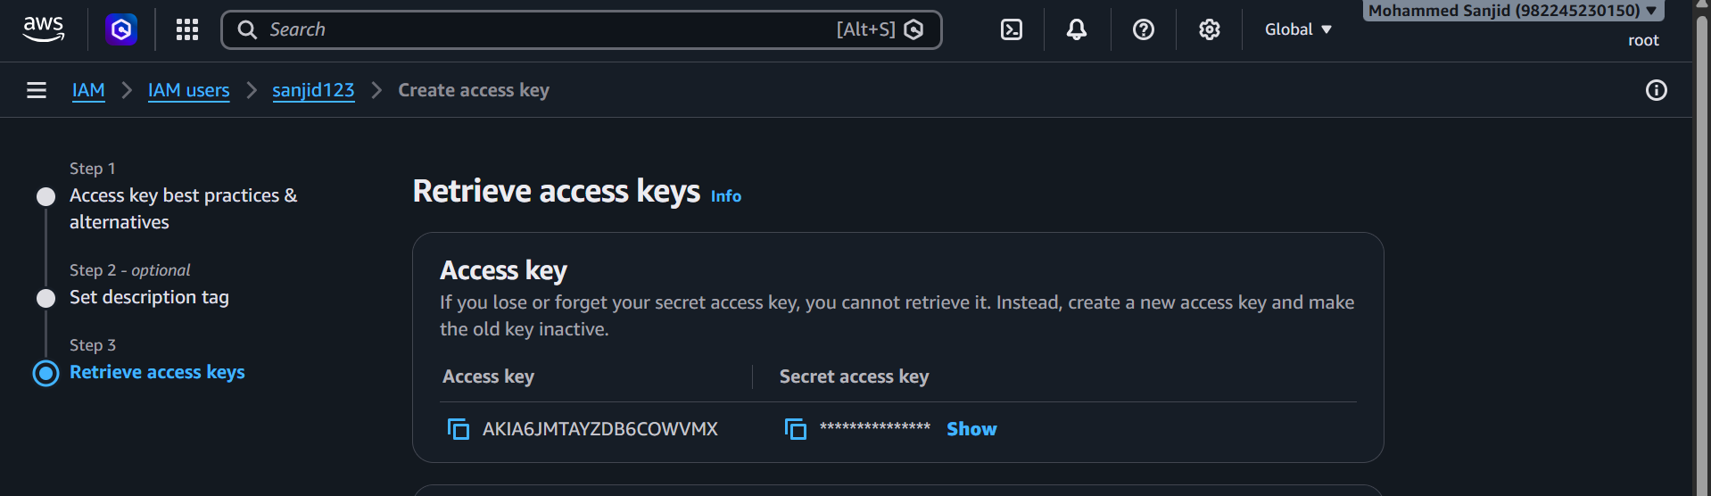

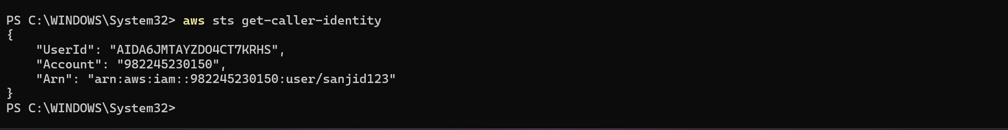

9. Testing EC2 Access Using AWS CLI
The following command was used to verify EC2 access in the Mumbai Region:
aws ec2 describe-instances
The command completed successfully and returned the EC2 response. An empty Reservations list indicates that the account had no EC2 instances, rather than indicating a permissions failure.

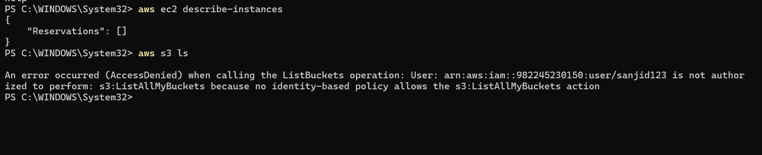

10. Testing Region Restriction Using AWS CLI
The same EC2 command was tested against a different AWS Region:
aws ec2 describe-instances --region us-east-1
The request returned an UnauthorizedOperation error, confirming that the IAM policy prevents EC2 access outside the Mumbai Region.

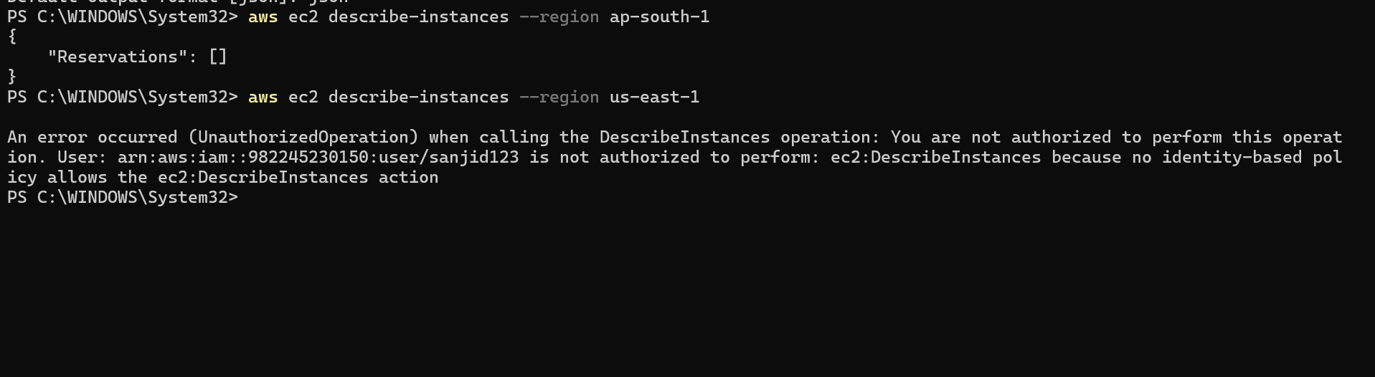

11. Testing S3 Access Using AWS CLI
Amazon S3 access was also tested using the AWS CLI:
aws s3 ls
The command returned AccessDenied, confirming that the IAM user does not have S3 permissions.

12. Conclusion
The IAM user sanjid123 was successfully created with restricted access to AWS EC2. A custom IAM policy, EC2-Mumbai-Only, was configured to allow EC2 access only in the Mumbai Region (ap-south-1).
The permissions were verified through both the AWS Management Console and AWS CLI. EC2 access in Mumbai was successful, while access to EC2 in other regions and access to S3 were denied.
This demonstrates how AWS IAM policies can be used to implement service-level and region-level access restrictions, providing controlled access according to specific requirements.

